**SQL**

Facts about SQL

1. It stands for Structured Query Language.
2. RDBMS (Relational Database Management System) supports SQL (MySQL).
3. MySQL is an open-source RDBMS.
4. It enables us to have CRUD (Create Read Update Delete) operations.
5. The SQL queries are written to interact with DB.
6. Keywords in SQL are case-insensitive for the most popular DBMSs but its suggested to use capital for keywords.

** “Var” is added at the start of a datatype name to make it of variable length.

Q1. Data types in SQL:

1. INT
2. FLOAT Decimal with precision to 23 digits
3. DOUBLE 🡪 Decimal with 24 to 53 digits
4. DECIMAL 🡪 Double stored as string
5. DATE 🡪 YYYY-MM-DD
6. DATETIME 🡪YYYY-MM-DD HH:MM:SS
7. ENUM
8. BOOLEAN 🡪 0/1 **internally implemented as TINYINT
9. CHAR 🡪 String (0-255) string with size = (0,255], eg., CH AR(251)
10. VARCHAR 🡪 different from char because it has variable size
11. TINYTEXT 🡪 string (0-225)
12. MEDIUMTEXT
13. LONGTEXT
14. TEXT 🡪 string (65535)
15. BLOB(Binary Large Objects) 🡪 audio/video stored in bytes.

SIGNED and UNSIGNED

TINYINT 🡪 (-128,127)

UNSIGNED TINYINT 🡪 (0-255)

Q2. Types of SQL commands

1. DDL (Data Definition Language)

CREATE

ALTER TABLE

DROP

TRUNCATE

RENAME

1. DRL/DQL (Data Retrieval/Query Language)

SELECT

1. DML (Data Modification Language)

INSERT

UPDATE

DELETE

1. DCL (Data Control Language)

GRANT

REVOKE

1. TCL (Transaction Control Language)

START TRANSACTION

COMMIT

ROLLBACK

SAVEPOINT

DDL

1. Creation of DB
2. CREATE DATABASE IF NOT EXISTS database_name;
3. USE database_name;
4. DROP DATABASE IF EXITS database_name;
5. SHOW DATABASE;

** lists all the database in the server

1. SHOW TABLES;

** list tables in the selected database

DQL

1. *SELECT <col_name1,col_name2,..> FROM <table_name>;*

**executed from right to left, the table is selected with “FROM” command and further the columns are selected.

1. WHERE
2. Reduces rows based on given conditions.
3. *SELECT * FROM <table_name> WHERE <condition>;*
4. *BETWEEN* 
   1. *Selects data in the given range eg. BETWEEN 0 AND 100, where 0 and 100 is inclusive.*
   2. *SELECT * FROM <table_name> WHERE age between 0 AND 100;*
5. IN
   1. Reduces OR condition
   2. *SELECT * FROM <table_name> WHERE <column_name> = “term1” OR <column_name> = “term2” OR <column_name> = “term3”*
   3. *SELECT * FROM <table_name> WHERE <column_name> IN (“term1”,” term2”, “term3”, “term4”)*

1. Find the duplicate row in a table.

SELECT name, section FROM table GROUP BY name, section HAVING COUNT(*) > 1

1. **Query to find 2nd highest salary of an employee?**

select *from employee group by salary order by salary desc limit 1,1;

1. **Find all the students, whose marks are greater than average marks i.e. list of above-average students.**

SELECT student, marks FROM table WHERE marks > SELECT AVG(marks) from table;

1. Nth highest salary

select * from employee order by salary desc limit n-1,1

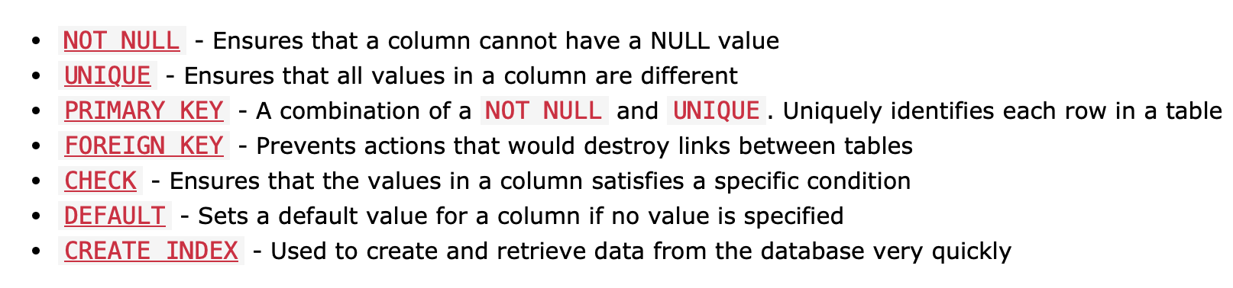Constraints

**foreign key

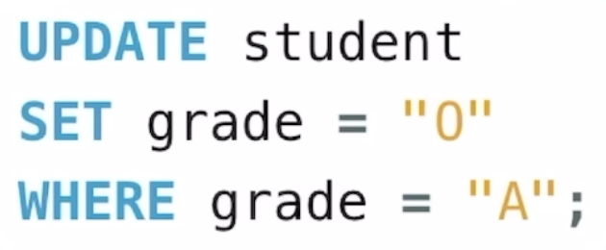REATE TABLE Orders (  
    OrderID int ,  
    OrderNumber int,  
    PersonID int,  
    PRIMARY KEY (OrderID),  
    FOREIGN KEY (PersonID) REFERENCES Persons(PersonID)  
);

**ALTER TABLE chan AUTO_INCREMENT=100;

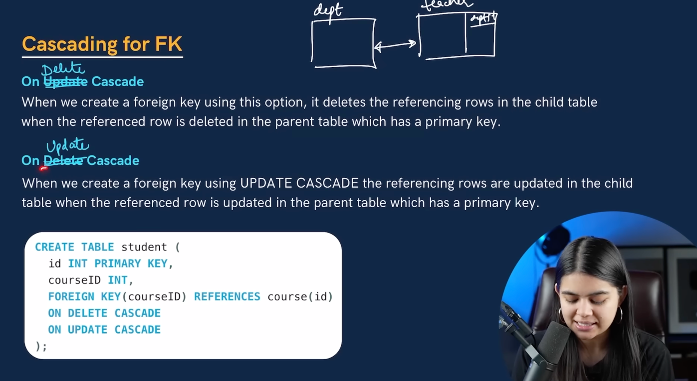

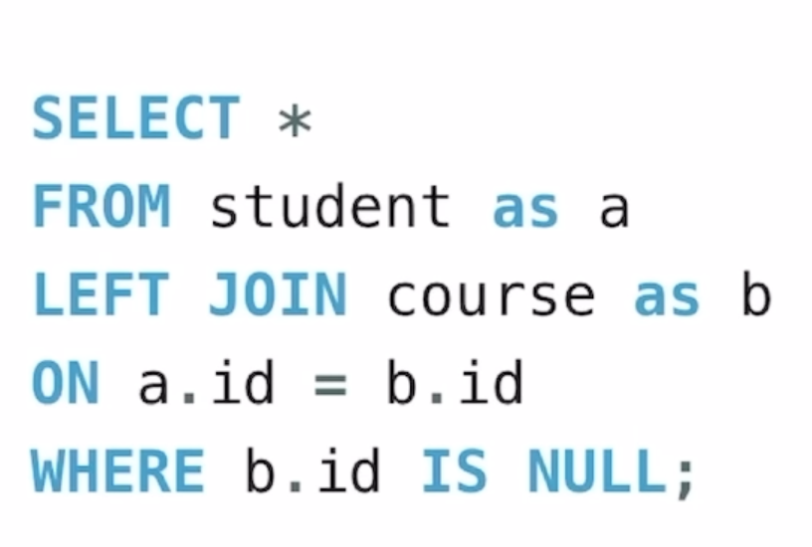

left excludive join

Select *from StuDetails where marks > (Select avg(marks) from StuDetails)

Select max(marks) from (select * from StuDetails where city = “delhi”) as temp

Select (select max(marks) form StuDetails) , name from StuDetails;